Filarecka Agnieszka, Leksowski Łukasz, Biernacki Maciej Jęchorek, Michał. Physical activity after breast cancer - conditions for practicing sports. Journal of Education, Health and Sport. 2022;12(10)60-65. eISSN 2391-8306. DOI http://dx.doi.org/10.12775/JEHS.2022.12.10.008
https://apcz.umk.pl/JEHS/article/view/40083
https://zenodo.org/record/7131409

The journal has had 40 points in Ministry of Education and Science of Poland parametric evaluation. Annex to the announcement of the Minister of Education and Science of December 21, 2021. No. 32343.
Has a Journal's Unique Identifier: 201159. Scientific disciplines assigned: Physical Culture Sciences (Field of Medical sciences and health sciences); Health Sciences (Field of Medical Sciences and Health Sciences).
Punkty Ministerialne z 2019 - aktualny rok 40 punktów. Załącznik do komunikatu Ministra Edukacji i Nauki z dnia 21 grudnia 2021 r. Lp. 32343. Posiada Unikatowy Identyfikator Czasopisma: 201159.
Przypisane dyscypliny naukowe: Nauki o kulturze fizycznej (Dziedzina nauk medycznych i nauk o zdrowiu); Nauki o zdrowiu (Dziedzina nauk medycznych i nauk o zdrowiu).
© The Authors 2022;
This article is published with open access at Licensee Open Journal Systems of Nicolaus Copernicus University in Torun, Poland
Open Access. This article is distributed under the terms of the Creative Commons Attribution Noncommercial License which permits any noncommercial use, distribution, and reproduction in any medium, provided the original author (s) and source are credited. This is an open access article licensed under the terms of the Creative Commons Attribution Non commercial license Share alike.
(http://creativecommons.org/licenses/by-nc-sa/4.0/) which permits unrestricted, non commercial use, distribution and reproduction in any medium, provided the work is properly cited.
The authors declare that there is no conflict of interests regarding the publication of this paper.
Received: 01.09.2022. Revised: 02.09.2022. Accepted: 30.09.2022.

Physical activity after breast cancer - conditions for practicing sports

Agnieszka Filarecka ¹, Łukasz Leksowski ², Maciej Biernacki ³, Michał Jęchorek ⁴

¹ Collegium Medicum, UMK Bydgoszcz, Chair and Clinic of Oncological Surgery
² Collegium Medicum, UMK Bydgoszcz, Clinic of Rehabilitation
³ Collegium Medicum, UMK Bydgoszcz, Chair and Department od Anatomy
⁴ "ToTu" Addiction Therapy Center in Karnice

Corresponding author:

mgr Agnieszka Filarecka
Collegium Medicum, UMK Bydgoszcz, hair and Clinic of Oncological Surgery
ul. Izabeli Romanowskiej 2, 85-796 Bydgoszcz, Poland
Tel. 503074346
e-mail: aga.filarecka@gmail.com

Summary
Physical activity is a vital part of your lifestyle. Reports on the positive effects of physical activity are widely discussed in the literature. However, there are also drawbacks to physical activity. One of the contraindications is neoplastic disease. Such reports pretend to reduce the activity in cancer patients.
The aim of the work is to present a method of modifying physical activity in women after breast cancer treatment in order to consolidate the rehabilitation therapy and the prevention of treatment-related disorders. The paper proposes the procedure and conditions for the implementation of physical activity.

Keywords: aerobics, fitness, breast cancer

- Introduction
The main method of treating breast cancer that may lead to a permanent cure is surgery [1]. It can be carried out using the mammary gland sparing method or the complete method, where the entire mammary gland is removed along with the lymphatic system of the armpit [2].
In addition to surgery, which is the first choice in the treatment of patients with this diagnosis, radiotherapy, chemotherapy, hormone therapy and other systemic treatments are used.
Regular participation in physical activity reduces the risk of postoperative complications, lymphoedema of the upper clover on the side of the operated breast, and prevents obesity, increasing the risk of cancer recurrence and hindering return to full physical fitness and maintaining correct body posture [3,4]. Taking up regular physical activity brings beneficial effects not only in the physical sphere, but also in the mental sphere and social relations [5, 6].
Therefore, it becomes justified to take up physical activity as soon as possible in women after surgery.
The basic problems that occur after the procedure are limited mobility and pain, which result in a number of changes in the structure of the body. Implemented quickly, physical activity will also help to prevent lymphedema.
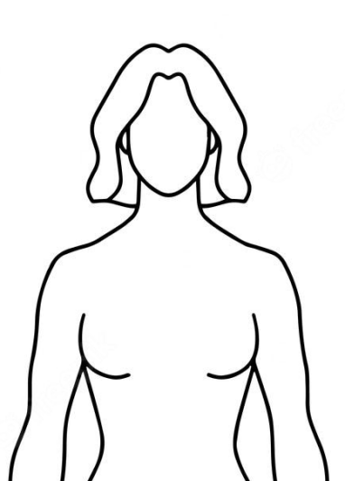
Rys. 1. Consequences of Radical Treatment of Breast Cancer.

- Literature review

The available literature includes reports of limb immobilization after surgery. Few reports mention anti-edema prophylaxis, however, with the use of compression methods.

  - Physical activity – conditions

Physical activity as a form of active participation in everyday activities increases energy expenditure, which contributes to weight loss. Additional benefits of systematic physical activity include:
• weight reduction, increase in muscle mass and increase in bone density,
• lowering insulin levels and improving glucose tolerance
• lowering of your resting and exercise blood pressure and heart rate
• improvement of fitness - injury prevention
• improving general well-being and improving mental health
• improvement of the emotional state (reduction of drug states, depression).
It is considered important to implement physical activity in women after surgery for the purpose of prophylaxis, but also for the continuation of treatment. The increase in mass and the increase in blood glucose concentration are one of the factors causing the appearance of neoplastic diseases [3,5].
Physical activity, both insufficient and too high, may be inappropriate for the patient [7].
When planning physical activity, the main problem of the patient should be taken into account. The ICF classification can be used for this. In a structured context, it executes measurement tests and tests, e.g. of the range of motion of SFTR. The purpose of performing the tests is to hypothesize the cause of the problem with performing daily activities (ADL). At the level of daily activity, repeatable measurable tests are performed [8, 9].
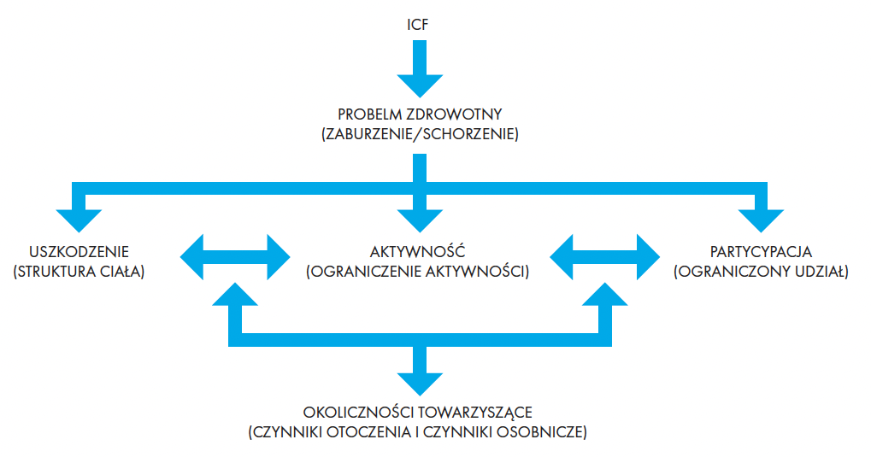
Ryc. 2. ICF

For women after amputation, the ICF classification may be as follows:
- at the structure level:
no slip between the pectoral muscle and the incision scar
surgical,
- at the level of activity:
limitation of upper limb flexion, abduction and external rotation,
- at the level of participation:
no combing possible.

An important element in physical activity is its intensity adapted to the patient's condition. It is important to remember about the diseases that will determine the intensity of physical activity. The limitations that determine the intensity include [6, 7]:
• cardiovascular failure,
• periods of exacerbation of coronary heart disease,
• uncontrolled hypertension,
• decompensated diabetes,
• acute infections, as well as inflammation and degenerative changes in the osteoarticular system, which make it impossible to perform physical exercises in its original form.

In the process of planning physical activity for patients, energy expenditure should be taken into account. Systemic treatment of neoplasm may have a negative impact on the level of nutrition, which means that the conditioning of physical activity depends on the level of nutrition [9, 10].
Physical activity in terms of daily energy expenditure is as follows [10]:
• resting metabolism - about 60–70% of the daily expenditure;
• physical effort or exercise - from about 15% of the daily expenditure in people leading a sedentary lifestyle to even 40% in people leading a very active lifestyle;
• food thermogenesis - about 10% of the daily energy expenditure.
It should be remembered that physical activity will depend on prior physical activity before the procedure.

- Physical activity - recommendations for women

After the analyzed literature and own experience, it is recommended to use physical activity both before and after the surgery.
The implementation of activity before the surgery will have a positive effect on reducing the risk of complications after surgery in the event of immobilization. The implementation of physical activity different from physiotherapy, on the other hand, will have a positive effect after the treatments, maintaining the therapeutic effect.
The recommendation for women after the procedure are classes that affect the overall fitness of the patient and also increase cardiovascular and respiratory efficiency. These activities include aerobic classes. The available forms for the use of general fitness activities include:
• fitness without load - dance classes, Zumba, etc.,
• Nordic walking
• Aquareobic
• Running
• Elliptical

It is important that the movements include both the lower and upper limbs. Therefore, it is not recommended to do cycling and activities that load only one muscle part in the phase immediately after the procedure.
In addition to the activity improving general efficiency, the activity associated with increasing the elasticity of tissues should be implemented. Recommended activities include:
• Pilates
• Yoga
•Healthy spine
• Mobility
•Stretching
The advantage of activities restoring flexibility is highlighting the therapeutic effect during physiotherapy.
In the proposed procedure for the implementation of physical activity, it is recommended to combine both forms.

After a period of 3 months after the wound has healed, it is recommended to implement weight-bearing exercises in order to rebuild muscle strength and increase it.
For this purpose, the following are used:
• Exercises with self-weight,
• Exercises with external load
• dumbbells,
• Barbell
• Expander
Physical activity should be fractionated, it is recommended to implement physical activity from 75 minutes a week, spread over 3 days, units of similar duration and average intensity. With good exercise tolerance, 2 weeks after starting physical activity, increase the amount of exercise while maintaining frequency. At a later stage, after 8 weeks, it is recommended to increase the intensity by 20% while leaving the frequency. The most important thing is the systematics of physical activity.

- Discussion
Physical activity is one of the elements of a lifestyle that is of key importance in maintaining the motor apparatus at an appropriate level of fitness and directly affecting the perceived quality of life.
Oncological patients show a reduced quality of life. The consequence of treatment (surgery, chemotherapy, radiotherapy) is a reduction in the quality of life, it is extremely important to look for interactions that can contribute to the return to optimal functioning and improve the quality of life.
For this reason, it becomes justified to define the principles of physical activity in women after surgical treatment of breast cancer. In the studies by Malicka et al., As many as 96% of respondents stated that regular participation in physical activity after oncological treatment is necessary and contributes to faster recovery [11].
The authors emphasize in their research the beneficial effect of medium-intensity exercise on the improvement of the functioning of the circulatory and respiratory system and increasing the body's efficiency. The same studies indicate that regular physical activity may weaken the negative effects of cancer treatment [11]. Regular exercise in women being treated for cancer is essential and has a significant impact in reducing the deficit in muscle function. Women participating in regular training also show better exercise capacity compared to inactive women. The authors indicate Nordic walking as one of the safe forms of physical activity in this group of patients, as it improves the functions of the upper limb muscle on the side of the operated breast, which does not lead to the risk of lymphoedema [8, 10].

- Summary Conclusion

The literature review and own results show that:
1. Physical activity should be started as soon as possible after breast cancer treatment
2. Physical activity should be undertaken rationally
3. Regular physical activity will be considered to prevent the occurrence of undesirable effects of treatment

Literature
- Wojciechowska U, Olasek P, Czauderna K, Didkowska J. Nowotwory złośliwe w Polsce w 2014 roku. Krajowy Rejestr Nowotworów, Warszawa 2016
- Czerniak A, Demuth U. Wpływ aktywności fizycznej na poczucie jakości życia kobiet leczonych z powodu nowotworu piersi. [w:] Aktywność ruchowa kobiet. Formy, uwarunkowania, korzyści, zagrożenia. Guszkowska M (red). Danmar, Warszawa 2009: 309-316.
- Malczyk E, Majkrzak Ż. Wybrane elementy stylu życia a ryzyko rozwoju raka piersi. Probl Hig Epidemiol 2014, 95(4): 827-830.
- Tchórzewska H., Rehabilitacja w leczeniu raka piersi. [W] Pawlicki M. (red.), Rak piersi — nowe nadzieje i możiwości leczenia. Wyd. 2. Alfa Medica-Press, Bielsko-Biała 2011: 99–120.
- Lupa A., Badania pacjenta zgodnie z wytycznymi ICF. Praktyczna Fizjoterapia i Rehabilitacja 2010; 5: 27‒33
- Mika K., Po odjęciu piersi. PZWL, Warszawa 2005.
- Jassem J, Krzakowski M (red.). Zalecenia postępowania diagnostyczno – terapeutycznego w nowotworach złośliwych. Rak piersi. 2013 (aktu alizacja: 11.2014): 230–246.
- Nowikiewicz T i wsp. Aktualne problemy dotyczące postępowania diagnostycznego oraz leczenia operacyjnego chorych na raka piersi – przegląd wybranych zagadnień klinicznych. Current Gynecologic Oncology. 2015; 13(1): 11–19.
- Kalinowski P. i wsp. Rola fizjoterapii po mastektomii w opinii pacjentek. Medycyna Ogólna i Nauki o Zdrowiu. 2012; 18(4): 291–296.
- Malicka I, Szczepańska-Gieracha J, Jankowska E, et al. Physical activity, life satisfaction and adjustment to illness in women after treatment of breast cancer. Współcz Onkol 2011, 15(3): 180-185.
- Hsieh CC, Sprod LK, Hydock DS, et al. Effects of a supervised exercise intervention on recovery from treatment regimens in breast cancer survivors. Oncol Nurs Forum 2008, 35(6): 909-915.

